EXPERIMENT NO. 10
AIM: to study the architecture and instruction set of 8085 microprocessor.
Theory: The 8085 is an 8-bit microprocessor, the configurations of 8085 microprocessor mainly include data bus-8-bit, address bus-16 bit, program counter-16-bit, stack pointer-16 bit, registers 8-bit, +5V voltage supply, and operates at 3.2 MHz single segment CLK. The applications of 8085 microprocessor are involved in microwave ovens, washing machines, gadgets, etc.
The 8085 Microprocessor Architecture
The architecture of the 8085 microprocessor mainly includes the timing & control unit, Arithmetic and logic unit, decoder, instruction register, interrupt control, a register array, serial input/output control. The most important part of the microprocessor is the central processing unit.Intel 8085 is an 8-bit, NMOS microprocessor designed by Intel in 1977.It has following configuration:
- It is a 40 pin I.C. package fabricated on a single LSI chip.
- The Intel 8085 uses a single +5Vd.c. supply for its operation.
- Intel 8085’s clock speed is about 3 MHz; the clock cycle is of 320ns.
- 8 -bit data bus.
- Address bus is of 16-bit, which can address up to 64KB
- 16-bit stack pointer
- 16-bit PC (Program Counter)
- Six 8-bit registers are arranged in pairs :BC, DE, HL

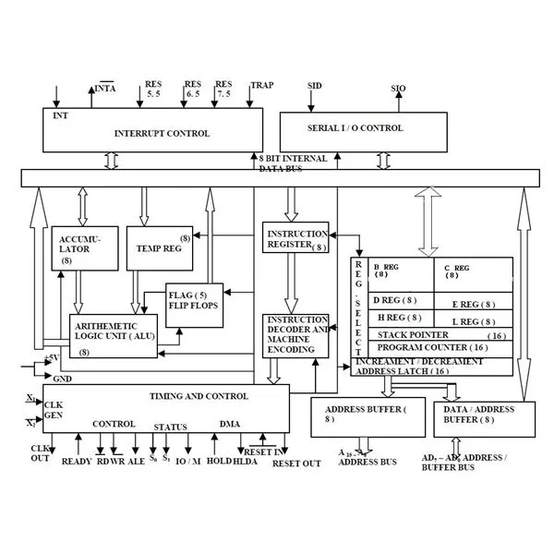

ALU

The Arithmetic and Logic Unit, ALU performs the arithmetic and logical operations such as Addition, Subtraction, Logical AND, Logical OR, Logical EXCLUSIVE OR, Complement (Logical NOT),Increment (add 1),Decrement (subtract 1),Left shift, Rotate left, Rotate right,Clear, etc.

Timing and Control Unit

The timing and control unit is the section of the CPU.
- It is used to generate timing and control signals which are necessary for the execution of instructions.
- It is used to control data flow between CPU and peripherals (including memory).
- It is used to provide status, control and timing signals which are required for the operation of memory and I/O devices.
- It is used to control the entire operations of the microprocessor and peripherals connected to it.
- Thus we can see that the control unit of the CPU acts as the brain of the computer system.

Registers: Registers are used for temporary storage and manipulation of data and instructions by the microprocessor. Data remain in the registers till they are sent to the I/O devices or memory. Intel 8085 microprocessor has the following registers:
- One 8-bit accumulator (ACC) i.e. register A
- Six general purpose registers of 8-bit, these are B,C, D, E, H and L
- One 16-bit stack pointer, SP
- One 16-bit Program Counter, PC
- Instruction registers
- Temporary register
- Flag Registers: The flag registers of microprocessor 8085 are classified into five types namely sign, zero, auxiliary carry, parity and carry. The positions of bit set aside for these types of flags. After the operation of an ALU, when the result of the most significant bit (D7) is one, then the sign flag will be arranged. When the operation of the ALU outcome is zero then the zero flags will be set. When the outcome is not zero then the zero flags will be reset.

Data and Address Bus: The Intel 8085 is an 8-bit microprocessor. Its data bus is 8-bit wide and therefore, 8 bits of data can be transmitted in parallel from or to the microprocessor. The Intel 8085 requires an address bus of 16-bit wide as the memory addresses are of 16-bits.

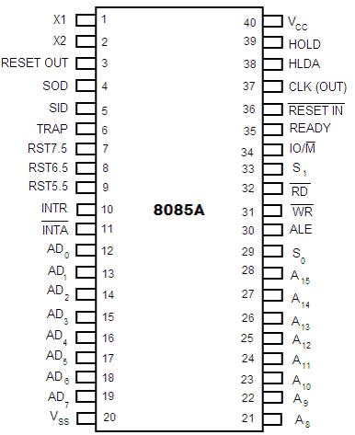
PIN CONFIGURATION:

8085 Instruction Sets
- control instructions

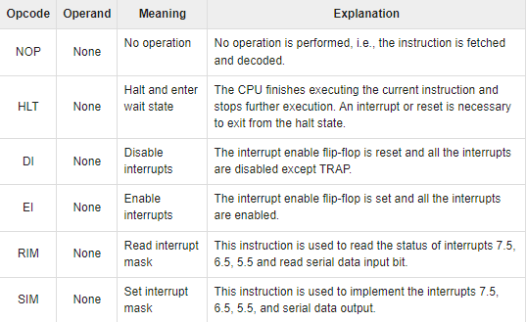

- logical instructions

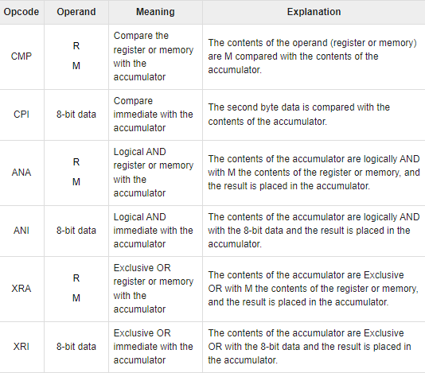

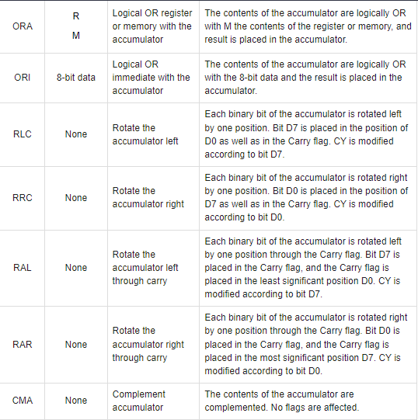

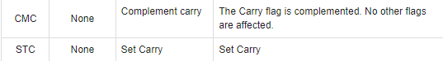
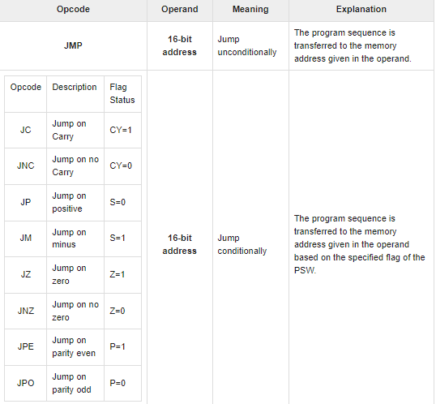
- branching instructions

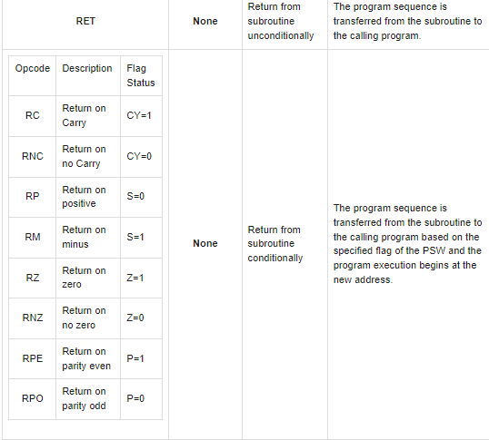
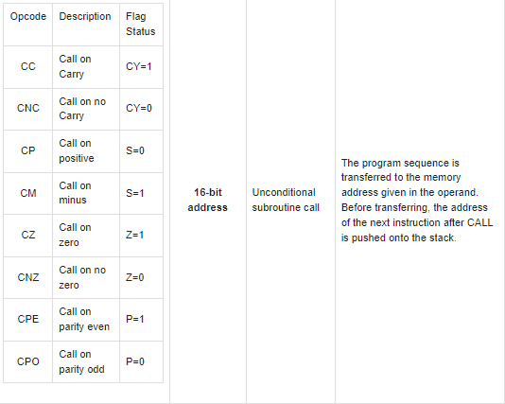
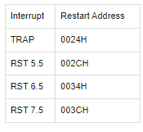
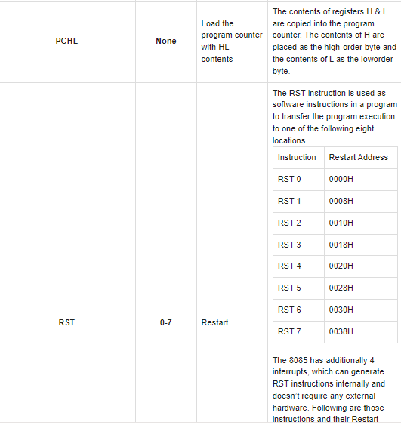
- Arithmetic instructions
Opcode | Operand | Meaning | Explanation
ADD | R  M | Add register or memory, to the accumulator | The contents of the register or memory are added to the contents of the accumulator and the result is stored in the accumulator.  Example − ADD K.
ADC | R  M | Add register to the accumulator with carry | The contents of the register or memory & M the Carry flag are added to the contents of the accumulator and the result is stored in the accumulator.  Example − ADC K
ADI | 8-bit data | Add the immediate to the accumulator | The 8-bit data is added to the contents of the accumulator and the result is stored in the accumulator.  Example − ADI 55K
ACI | 8-bit data | Add the immediate to the accumulator with carry | The 8-bit data and the Carry flag are added to the contents of the accumulator and the result is stored in the accumulator.  Example − ACI 55K
LXI | Reg. pair, 16bit data | Load the register pair immediate | The instruction stores 16-bit data into the register pair designated in the operand.  Example − LXI K, 3025M
DAD | Reg. pair | Add the register pair to H and L registers | The 16-bit data of the specified register pair are added to the contents of the HL register.  Example − DAD K
SUB | R  M | Subtract the register or the memory from the accumulator | The contents of the register or the memory are subtracted from the contents of the accumulator, and the result is stored in the accumulator.  Example − SUB K
SBB | R  M | Subtract the source and borrow from the accumulator | The contents of the register or the memory & M the Borrow flag are subtracted from the contents of the accumulator and the result is placed in the accumulator.  Example − SBB K
SUI | 8-bit data | Subtract the immediate from the accumulator | The 8-bit data is subtracted from the contents of the accumulator & the result is stored in the accumulator.  Example − SUI 55K
XCHG | None | Exchange H and L with D and E | The contents of register H are exchanged with the contents of register D, and the contents of register L are exchanged with the contents of register E.  Example − XCHG
INR | R  M | Increment the register or the memory by 1 | The contents of the designated register or the memory are incremented by 1 and their result is stored at the same place.  Example − INR K
INX | R | Increment register pair by 1 | The contents of the designated register pair are incremented by 1 and their result is stored at the same place.  Example − INX K
DCR | R  M | Decrement the register or the memory by 1 | The contents of the designated register or memory are decremented by 1 and their result is stored at the same place.  Example − DCR K
DCX | R | Decrement the register pair by 1 | The contents of the designated register pair are decremented by 1 and their result is stored at the same place.  Example − DCX K
DAA | None | Decimal adjust accumulator | The contents of the accumulator are changed from a binary value to two 4-bit BCD digits.  If the value of the low-order 4-bits in the accumulator is greater than 9 or if AC flag is set, the instruction adds 6 to the low-order four bits.  If the value of the high-order 4-bits in the accumulator is greater than 9 or if the Carry flag is set, the instruction adds 6 to the high-order four bits.  Example − DAA

- Data transfer instructions
Opcode | Operand | Meaning | Explanation
MOV | Rd, Sc  M, Sc  Dt, M | Copy from the source (Sc) to the destination(Dt) | This instruction copies the contents of the source register into the destination register without any alteration.  Example − MOV K, L
MVI | Rd, data  M, data | Move immediate 8-bit | The 8-bit data is stored in the destination register or memory.  Example − MVI K, 55L
LDA | 16-bit address | Load the accumulator | The contents of a memory location, specified by a 16-bit address in the operand, are copied to the accumulator.  Example − LDA 2034K
LDAX | B/D Reg. pair | Load the accumulator indirect | The contents of the designated register pair point to a memory location. This instruction copies the contents of that memory location into the accumulator.  Example − LDAX K
LXI | Reg. pair, 16-bit data | Load the register pair immediate | The instruction loads 16-bit data in the register pair designated in the register or the memory.  Example − LXI K, 3225L
LHLD | 16-bit address | Load H and L registers direct | The instruction copies the contents of the memory location pointed out by the address into register L and copies the contents of the next memory location into register H.  Example − LHLD 3225K
STA | 16-bit address | 16-bit address | The contents of the accumulator are copied into the memory location specified by the operand.  This is a 3-byte instruction, the second byte specifies the low-order address and the third byte specifies the high-order address.  Example − STA 325K
STAX | 16-bit address | Store the accumulator indirect | The contents of the accumulator are copied into the memory location specified by the contents of the operand.  Example − STAX K
SHLD | 16-bit address | Store H and L registers direct | The contents of register L are stored in the memory location specified by the 16-bit address in the operand and the contents of H register are stored into the next memory location by incrementing the operand.  This is a 3-byte instruction, the second byte specifies the low-order address and the third byte specifies the high-order address.  Example − SHLD 3225K
XCHG | None | Exchange H and L with D and E | The contents of register H are exchanged with the contents of register D, and the contents of register L are exchanged with the contents of register E.  Example − XCHG
SPHL | None | Copy H and L registers to the stack pointer | The instruction loads the contents of the H and L registers into the stack pointer register. The contents of the H register provide the high-order address and the contents of the L register provide the low-order address.  Example − SPHL
XTHL | None | Exchange H and L with top of stack | The contents of the L register are exchanged with the stack location pointed out by the contents of the stack pointer register.  The contents of the H register are exchanged with the next stack location (SP+1).  Example − XTHL
PUSH | Reg. pair | Push the register pair onto the stack | The contents of the register pair designated in the operand are copied onto the stack in the following sequence.  The stack pointer register is decremented and the contents of the high order register (B, D, H, A) are copied into that location.  The stack pointer register is decremented again and the contents of the low-order register (C, E, L, flags) are copied to that location.  Example − PUSH K
POP | Reg. pair | Pop off stack to the register pair | The contents of the memory location pointed out by the stack pointer register are copied to the low-order register (C, E, L, status flags) of the operand.  The stack pointer is incremented by 1 and the contents of that memory location are copied to the high-order register (B, D, H, A) of the operand.  The stack pointer register is again incremented by 1.  Example − POPK
OUT | 8-bit port address | Output the data from the accumulator to a port with 8bit address | The contents of the accumulator are copied into the I/O port specified by the operand.  Example − OUT K9L
IN | 8-bit port address | Input data to accumulator from a port with 8-bit address | The contents of the input port designated in the operand are read and loaded into the accumulator.  Example − IN5KL

